Name : Mriganka Patra
Email – mriganka.patra@cognizant.com
Emp id - 2415820

Assignment 1:
Salesforce CRM – List Views, Workflows, Validation and Security
Objective:
Apply Advanced features of Salesforce such as creating list views, implementing automation via workflows, and enforcing data integrity and security rules.
Tasks:
- Create a list view for the “Project” object to display all records with a ‘Status’ in progress
- Define a workflow process to automatically send an email when a projects status is updated to ‘complete’
- Create a validation rule to ensure ‘End Date’ is always after ‘Start Date’
- Set field-level security to restrict access to the ‘Budget’ field for a specific profile
- Configure Object-level permissions to control create , read and edit rights for the ‘ Project Object’
Deliverables:
- Configures of list views and workflows
- Validation rule logic and test result
- Security settings applied with profile details

Task 1: Create a list view for the “Project” object to display all records with a ‘Status’ in progress

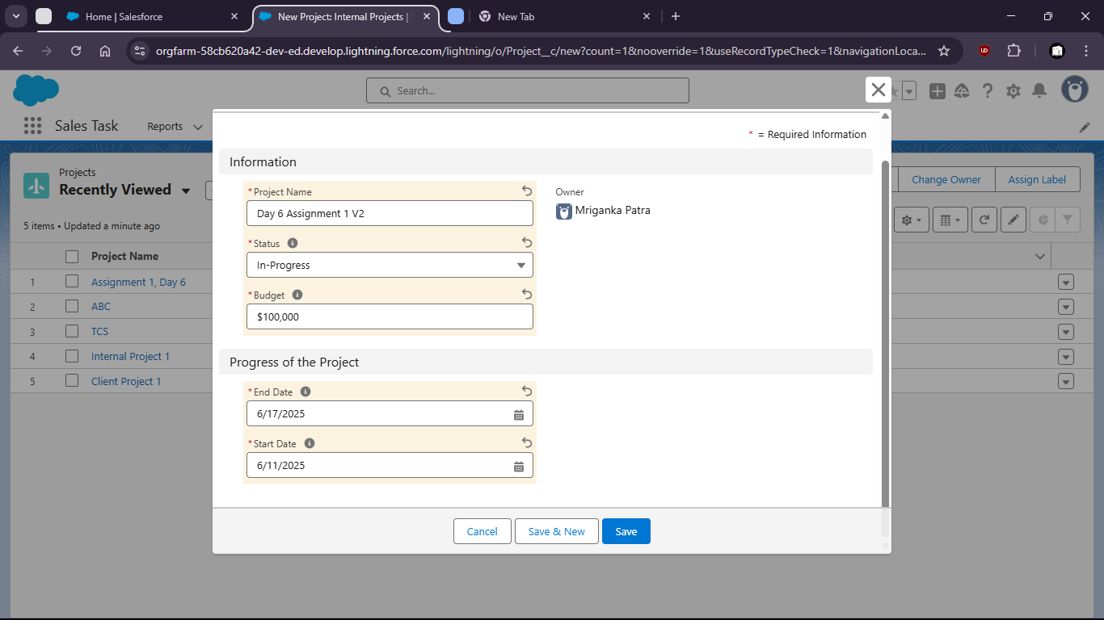

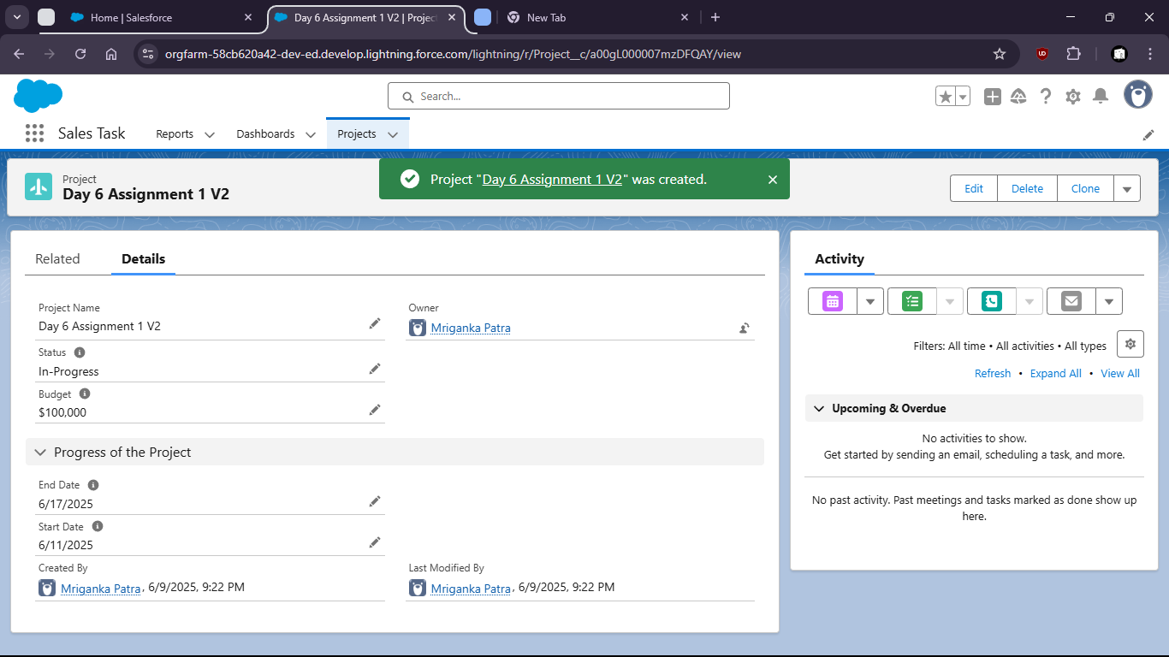

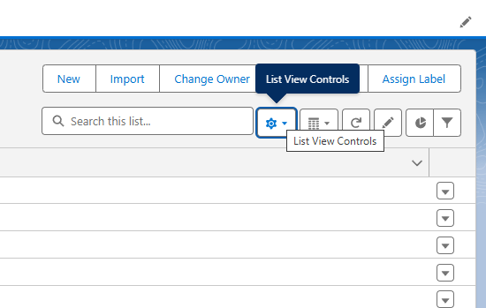

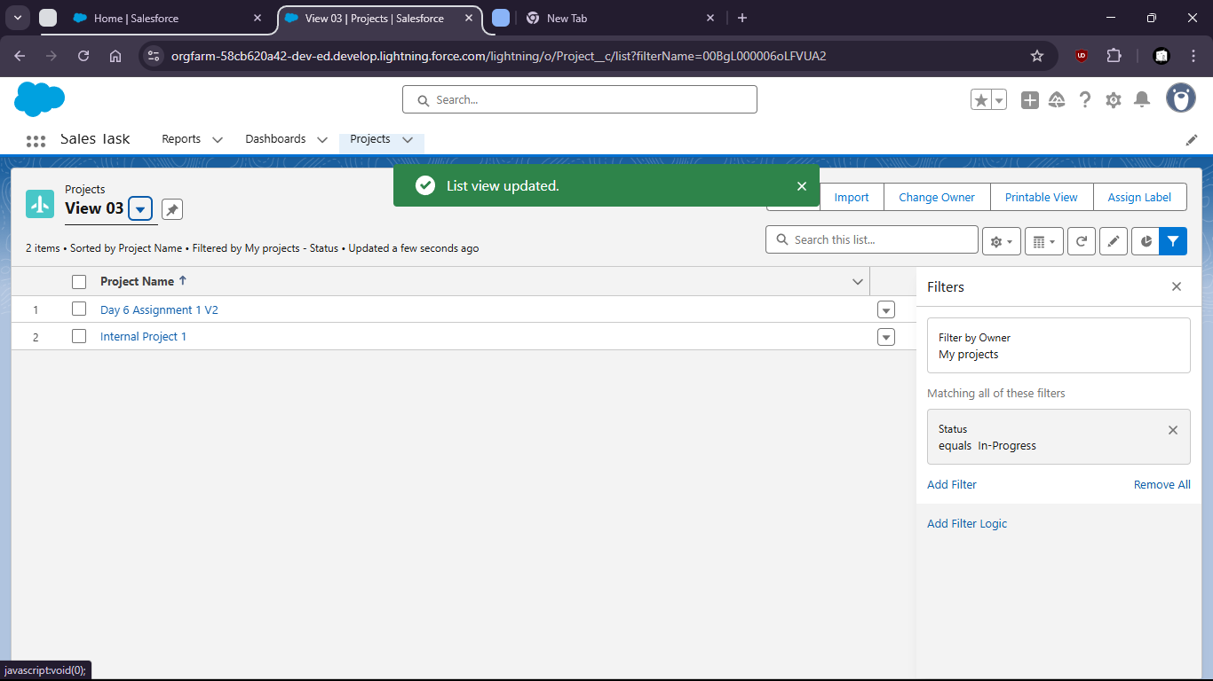

2. Define a workflow process to automatically send an email when a projects status is updated to ‘complete’

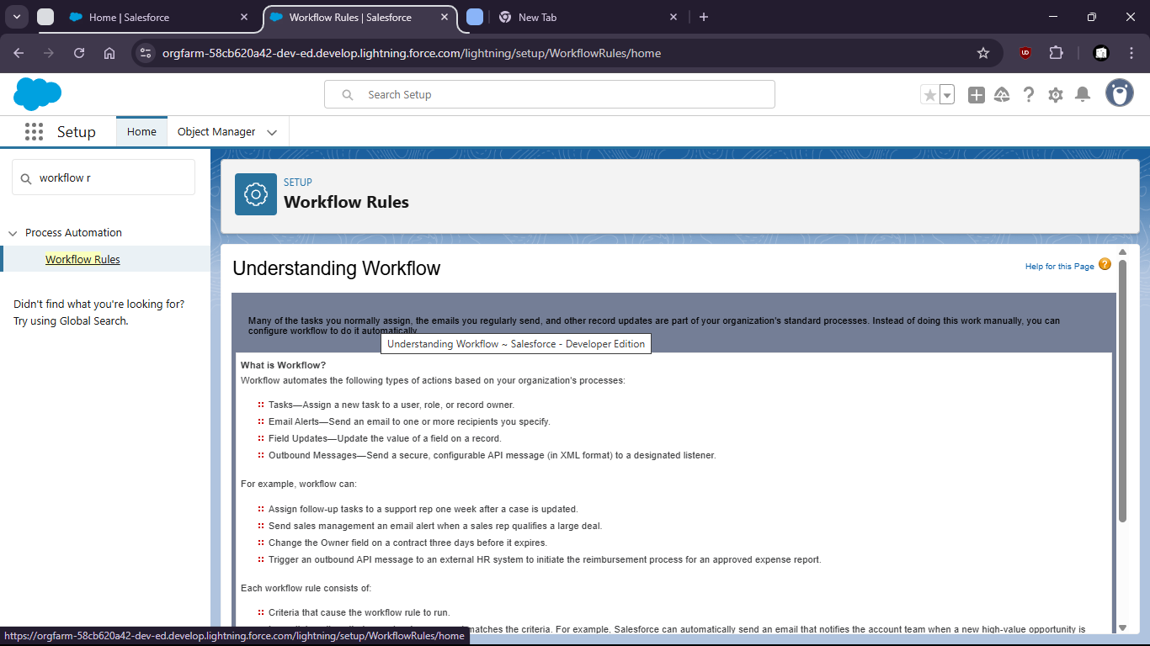

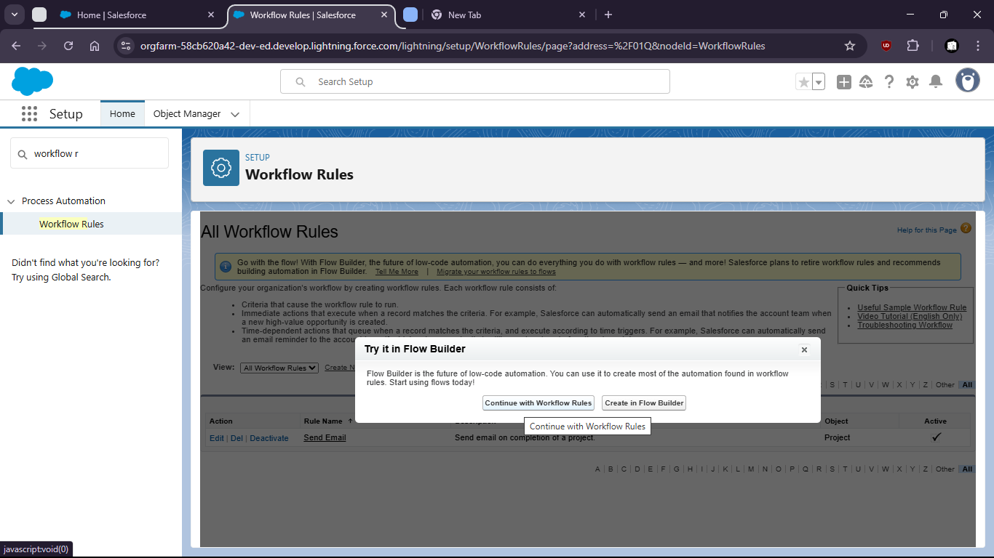

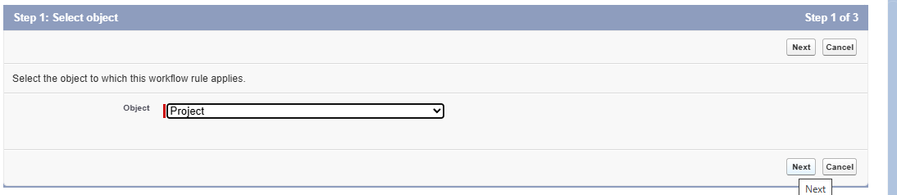

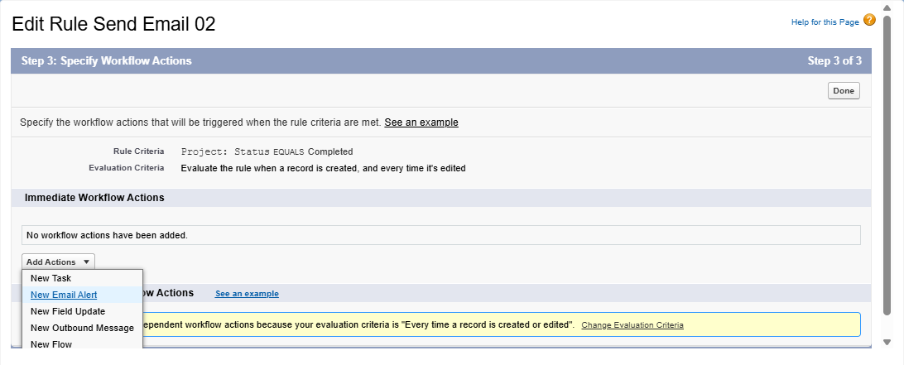

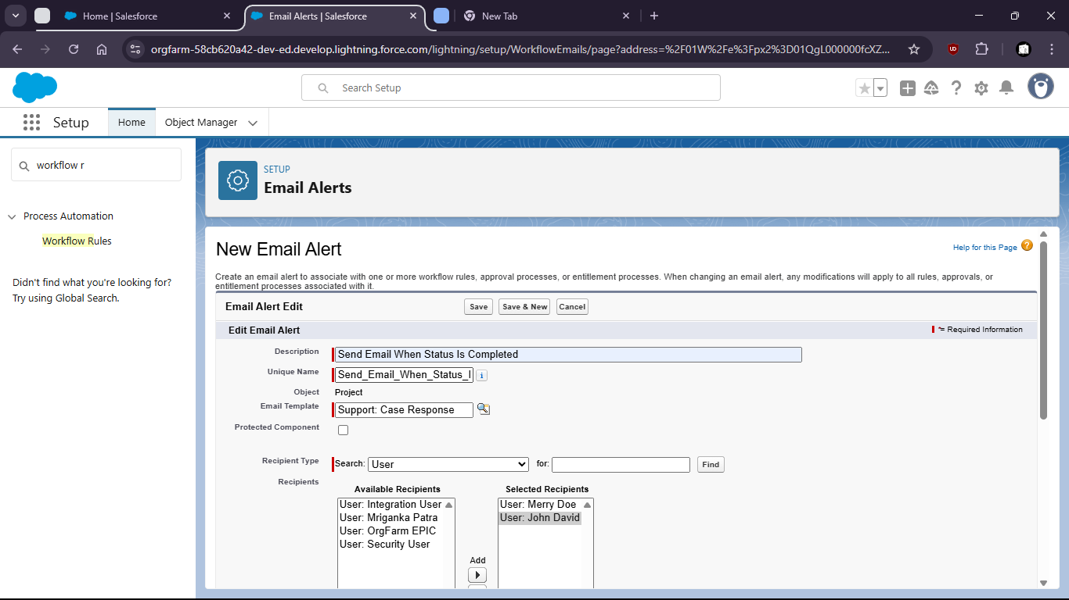

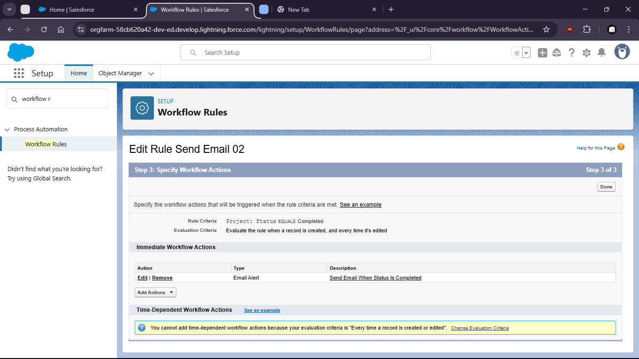

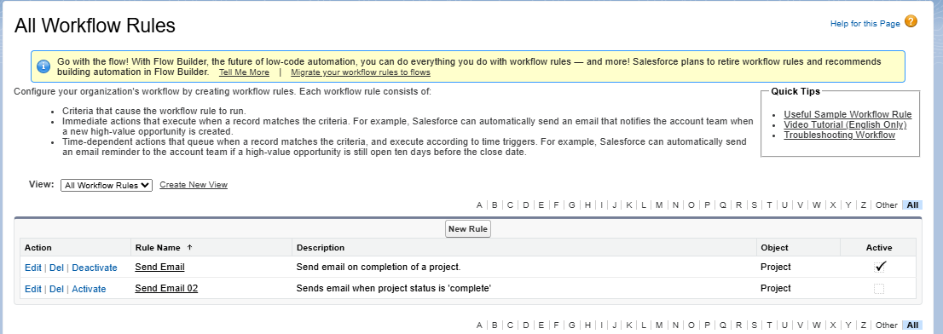

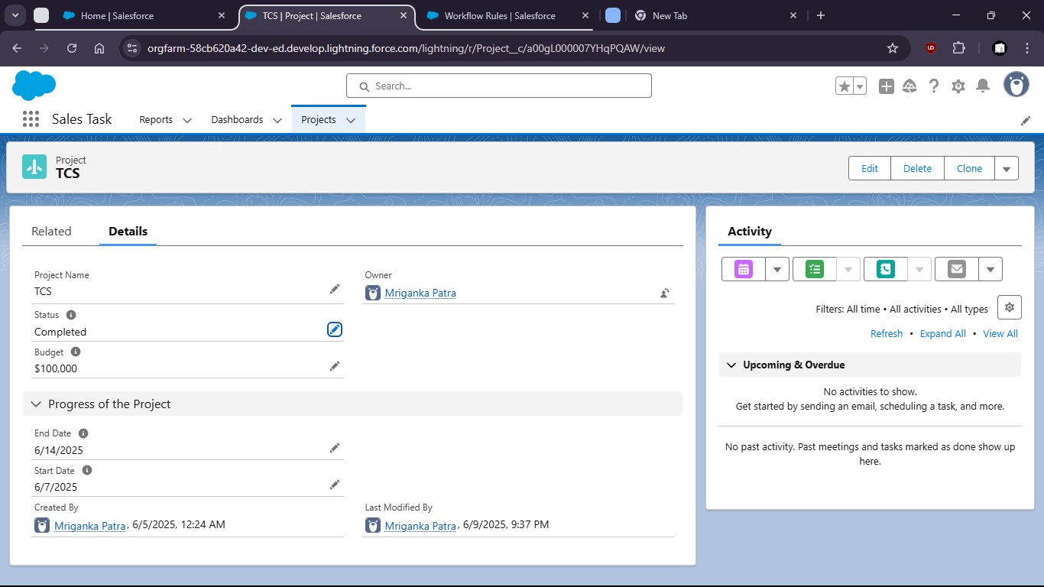

Task 3 : Create a validation rule to ensure ‘End Date’ is always after ‘Start Date’

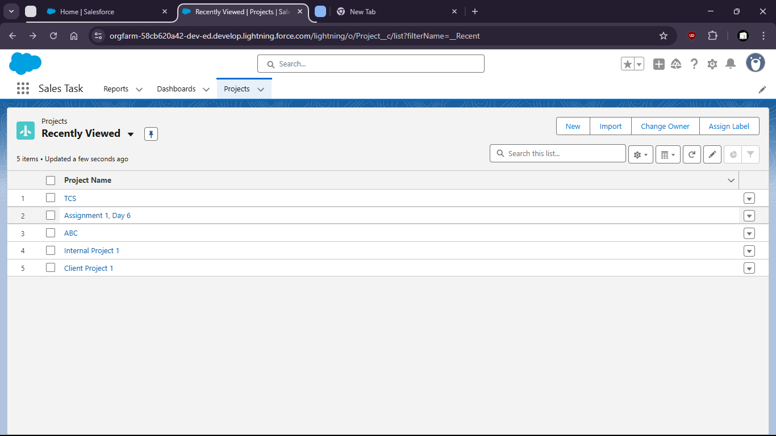

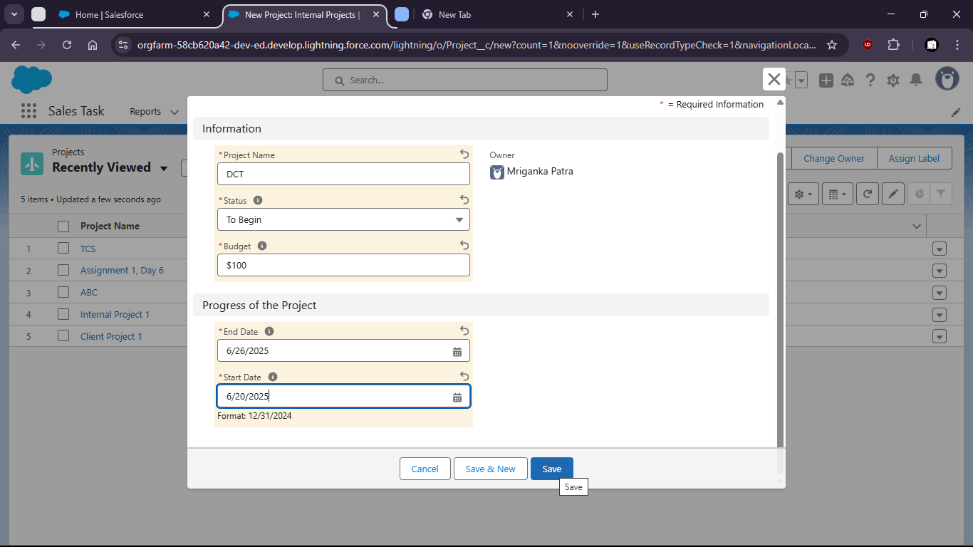

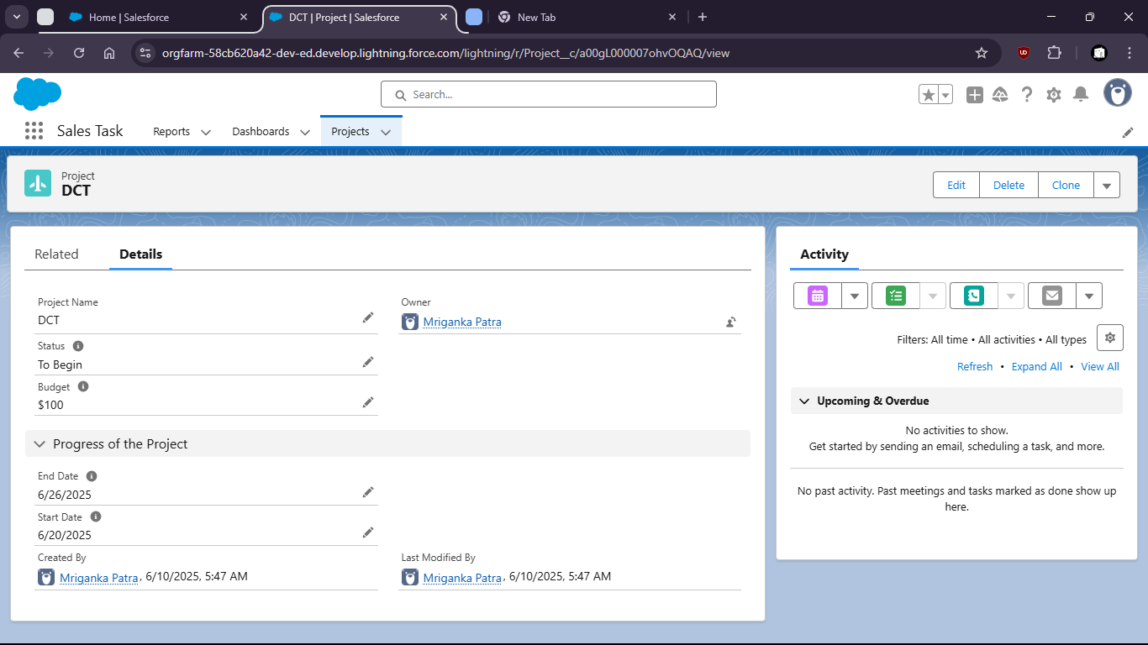

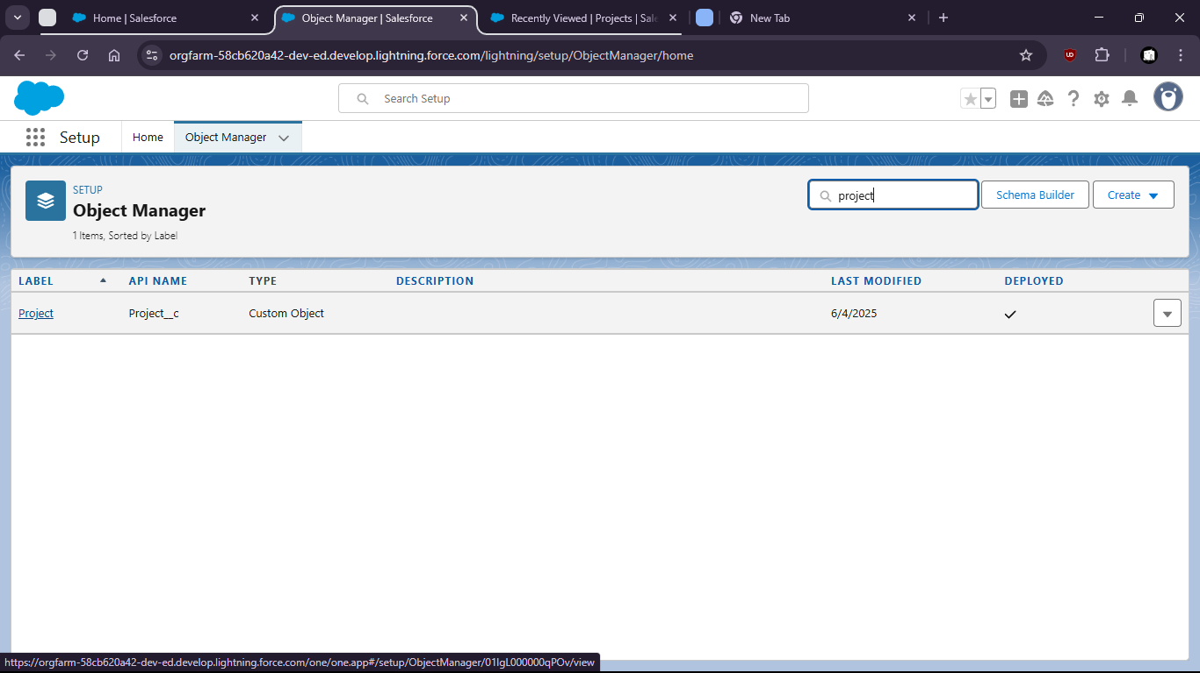
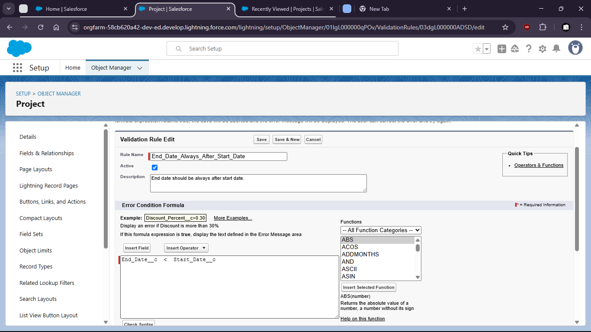

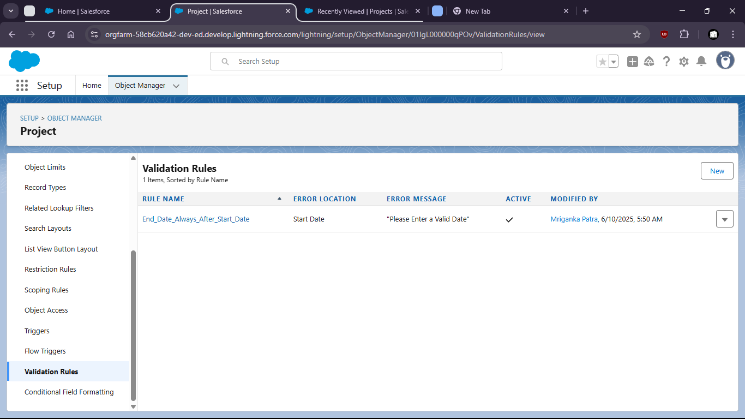

After Setting Rule End data can’t be before Start Date

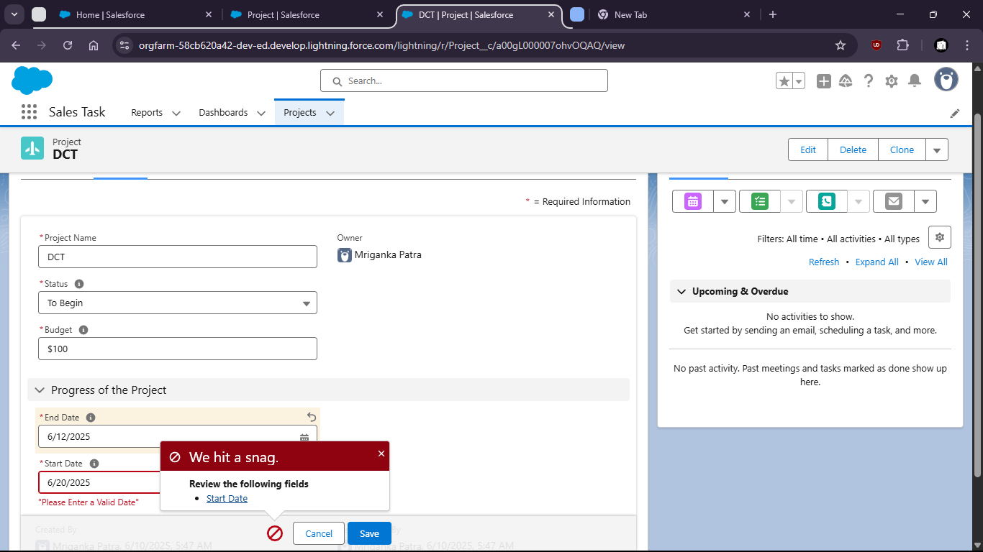

Task 4 : Set field-level security to restrict access to the ‘Budget’ field for a specific profile

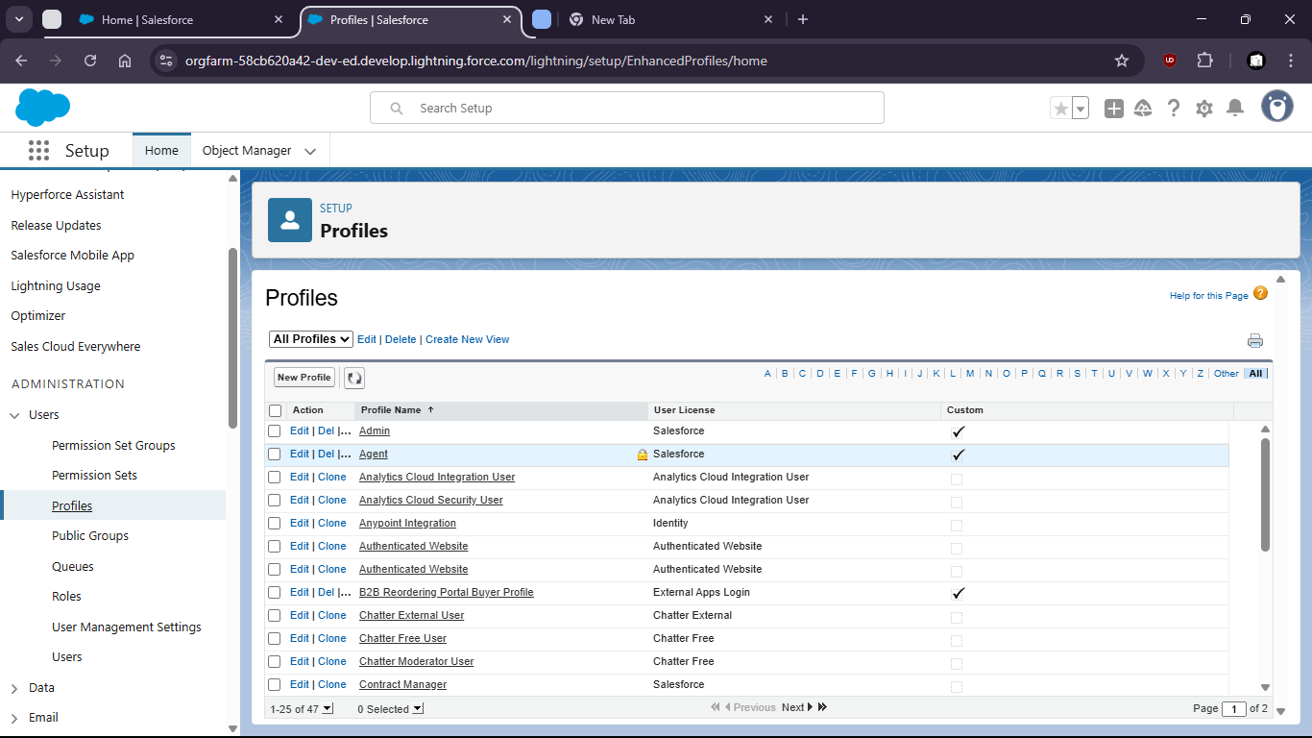

First check for “Project”

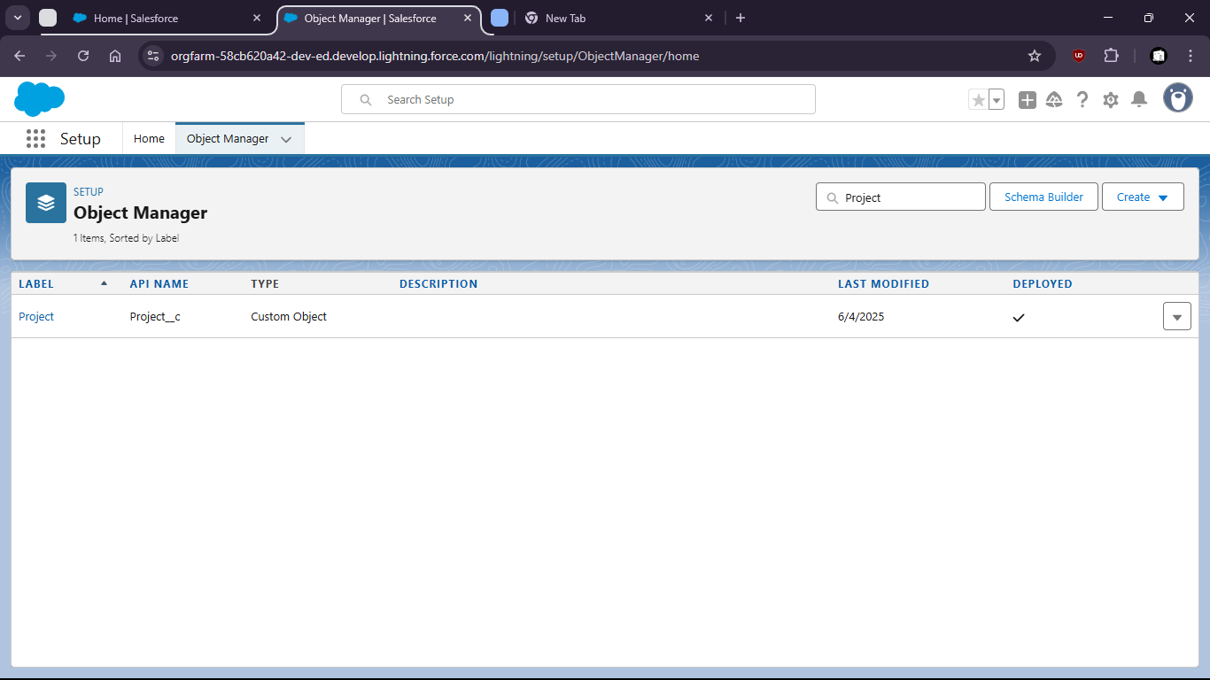

Then create custom field “Budget” if not present. With it being not always required.

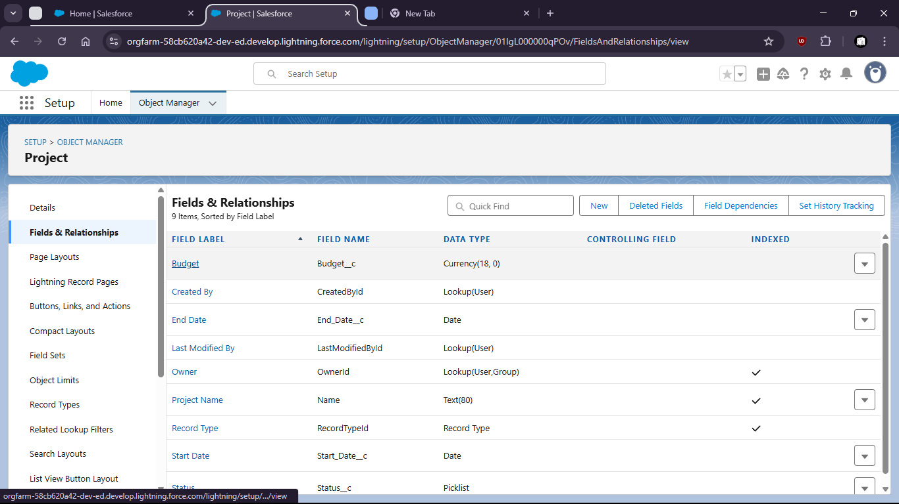
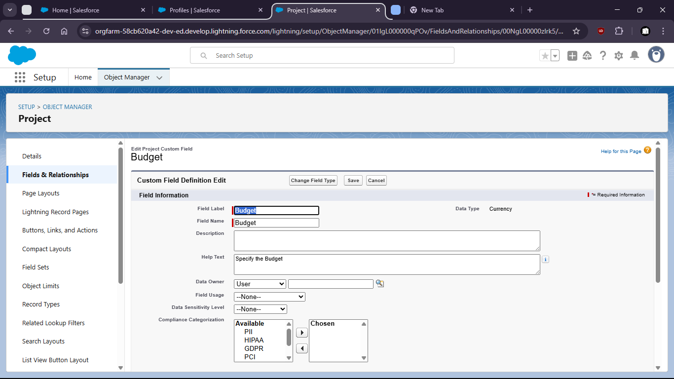

Goto profiles > field level security > Custom Field “Project” [view] > Make Changes

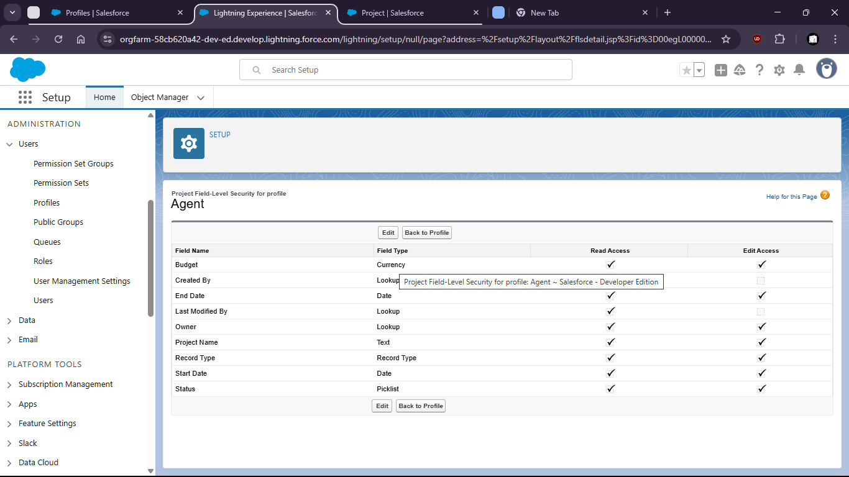

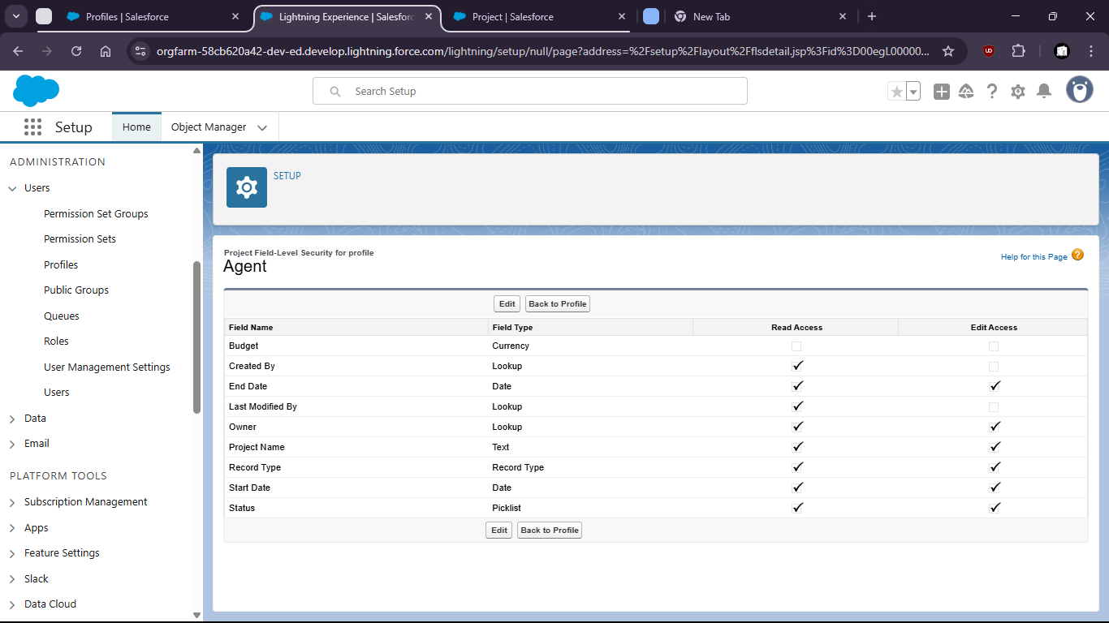

Task 5: Configure Object-level permissions to control create , read and edit rights for the ‘ Project Object’

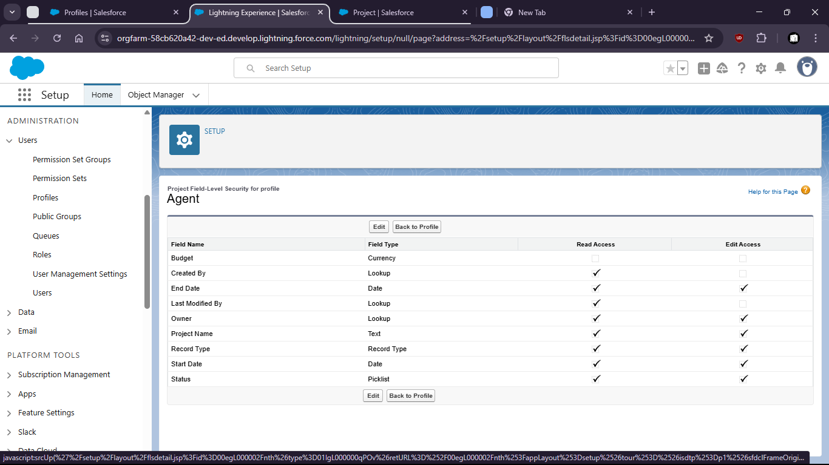

Standard Object Permission

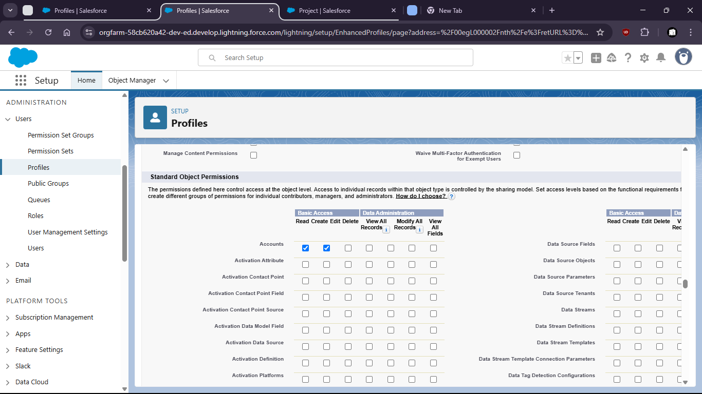

Custom Object Permission

